**ATAR HUMAN BIOLOGY**

**Unit 2**

**Task 8:DNA, Cell & Human Reproductive Systems**

**Name:**  **Weighting 5%**

**Date:**  **Mark /60**

**Answer scheme**

1. A B C D

2. A B C D

3. A B C D

4. A B C D

5. A B C D

6. A B C D

7. A B C D

8. A B C D

9. A B C D

10. A B C D

1. In the space below:
2. Draw a diagram of a section of DNA showing the major components. (1 mark)
3. Label the main components that make up the DNA structure. !/2 a mark each label, ½ for base attached to sugar (2 marks)
4. Circle one nucleotide. (1 mark)



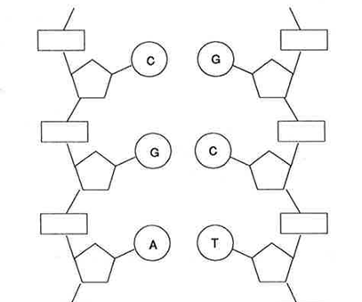

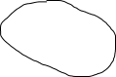

1. Use the table below to complete the summary of mitosis. Name the stages described or outline the key events occurring at each stage named. NOTE: Stages are NOT listed IN ORDER. (4 marks)

|  |  |
| --- | --- |
| **Stage** | **Events** |
| Telophase | Nuclear membranes and nucleoli form; chromosomes uncoil and disappear |
| Anaphase | spindle fibres pull chromosomes apart, 46 chromosomes to each side |
| Metaphase | Sister chromatids line up on equator, attached by centromere |
| Eg prophase  Or Interphase | Chromosomes copy themselves, nuclear membrane disappears, centromeres appear, spindle fibres start to form – any two points  Interphase – chromatin coils into chromosomes, |

1. Use the table below to show **two differences** and **one similarity** between the processes of mitosis and meiosis. (3 marks)

|  |  |  |
| --- | --- | --- |
|  | **Mitosis** | **Meiosis** |
| Differences (2)   * Chromosome number in cells made * Place * Purpose * Number divisions * Cells made | 46  Everywhere  Repair, growth, renewal  1  2 | 23  Ovaries, testes  Gamete production  2  4 |
| Similarities (1) | Chromosomes copied before division, spindle fibres form, centromere attaches to sister chromatids etc | |

4. Label the summary of protein synthesis diagrammed below. (1/2 a mark each)

The process that happens here is TRANSCRIPTION

Amino acid

Polypeptide chain

Anticodon

Ribosome

The process that happens here is TRANSLATION

1. Once the RNA polymerase has attached to the DNA, explain the sequence of events that happen in the nucleus as part of protein synthesis. Include all relevant names. (4 marks)

**FOUR OF THE FOLLOWING:**

* RNA polymerase starts reading the code at the start codon /stops at the stop codon
* Moves along the gene breaking open the hydrogen bonds/unzips the gene
* As moves along creates a piece of mRNA
* Code on mRNA is complementary to the code on DNA
* Triplet codes on the DNA and codons on the mRNA
* Uracil replaces thymine on mRNA

6. a) label the following structures

A – seminal vesicle (1)

B – Cowpers gland/Bulbourethral gland (1)

b) State the function of the following structures:

E : temperature control of testes stated (1)

G: carry sperm/semen and urine out of body (need both) (1)

1. If a male developed prostate cancer and had to have his prostrate removed would he still be able to have children with his partner by natural means? Explain your answer. (3 marks)

*No.*

Prostrate provide alkaline fluid to protect and (activate sperm) (1)

No protection from acid so acid will kill sperm (1)

Sperm not activated (as no alkaline to react with acid) (1)

***If answer yes and they have given a logical reasons can also mark as correct.***

1. a) State two important differences between the formation or characteristics of the spermatozoa and

the ova. (4 marks)

|  |  |  |
| --- | --- | --- |
| **Difference** | **Spermatozoa** | **Ova** |
| One | Small (1) | Large (1) |
| Two | Tail so mobile (1) | No tail/immobile (1) |

b) Choose one of the differences described in part f) (i) and explain how the process of reproduction would be affected if that difference did not exist. (2 marks)

if no tail the sperm would not be able to swim to the egg to fertilise it (1),

if egg mobile hard to catch reduce chance of fertilisation (1)

**or**

if sperm big would not fit through cervix so couldn’t fertilise egg(1),

if egg too small not enough nutrients to divide into ball of cells so can implant (1)

*accept suitable reasons as to why but must be linked to reproduction process.*

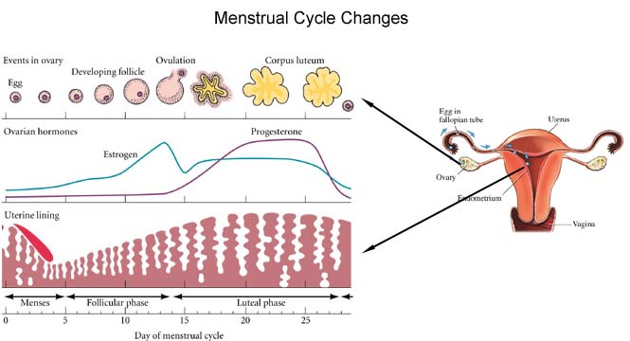

1. What hormones are represented by the lines on the graph and explain how you came to your conclusion. (3 marks)

***Oestrogen and progesterone (1)***

***One starts when follicle begins to mature and increases – oestrogen (1), other starts when corpus luteum made which makes progesterone (correct descriptions) (1)***

1. Many features of both reproductive systems depend on the endocrine glands for their regulation. The endocrine glands produce many hormones each has a specific target organ and effect.

Complete the following table identifying the hormones specific target organ(s) and its effect(s) in both male and females. (4 marks)

|  |  |  |
| --- | --- | --- |
| **Hormone** | **Target organ(s)** | **Effect(s) of hormone** |
| LH | Ovaries and testes | F- causes ovulation (1)  M – stimulates interstitial cells to make testosterone (1) |
| FSH | Ovaries and testes | F – causes the follicle to start to mature (1)  M – starts process of spermatogenesis (1) |

1. As the blastocyst develops into the embryo, there are three primary germ layers that develop first within the blastocyst, give two examples of structures that will be formed by the stem cells found in each of the primary germ layers. (3 marks)

Each layer must give two examples for the mark:

Endoderm *epithelial layers alimentary canal, lungs, bladder etc*

Mesoderm *bone, muscle, blood, connective tissue etc*

Ectoderm *nervous system, epidermis of skin, hair, nails etc*

1. Once the blastocyst implants the placenta starts to form and takes about 3 months till it is fully functional. Discuss why an embryo/foetus would need such an organ as the placenta. (4 marks)

Embryo cannot breathe as lungs full of liquid - Placenta enables oxygen from mother’s blood to diffuse into foetal blood and CO2 from foetal to maternal (1)

Embryo cannot eat food as in womb - Placenta enable nutrients from mother’s blood to pass into foetal blood (1)

Embryo cannot get rid of waste - Placenta enables waste to diffuse from foetal blood into maternal so it can be removed by mother (1)

No placenta there would be no hormones being made to hold the lining in place so it would be shed by the body. (1)

**Extended response (5 marks)**

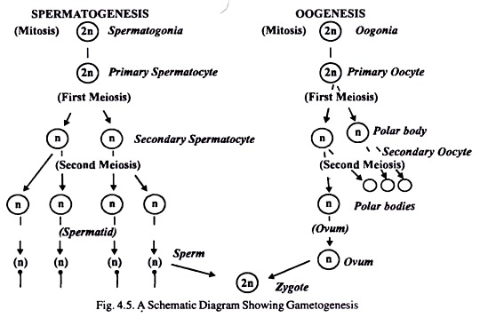Explain the stages that occur, after puberty, during Oogenesis. Include relevant names and places where events occur.

Primary follicle ½ mark or label secondary follicle ½ mark

½ mark

½ mark for either showing prophase I, or ½ mark for showing metaphase II

½ mark

½ mark

Ovary ½ mark

½ mark for ovulation

Fallopian tube ½ mark

*Oogenesis only complete*

½ mark

*if fertilisation occurs(1/2 mark)*